1. Branches in AzureDevOps repo

* Each commit has an ID, User Info (the name of the person who does the particular commit), details of changes.
* With each commit Git extracts all those information with the help of pointer. Git creates a snapshot of all changes in all commits in its own database. All files are also stored in Git’s own database.
* When you create a new commit, the new commit will also have information of Id, User Info, details of changes etc. The pointer which was pointing to the previous commit is now pointing to the current commit. The pointer has all information of the previous commit as well as the current commit. To name the pointer, we call it branch.
* Branch is the name of the pointer that keeps track of the changes made in each commit.
* When a repository is created in Azure DevOps, a new branch is created automatically for you. By default, its name is main.
* A new branch is a new pointer which has information some previous commits. Instead of calling it pointer, we give it a new name, the name of the new branch.
* When creating a new branch, the new branch does not copy the entire code. It only copies the pointer. Your entire file is not copied two times. Only the pointer is copied two times. To manage all the changes, Git uses pointer snapshots, or in technical terms reference management for pointers to point to the files.
* From each commit we can create a new branch. When the new branch is done, we can merge the new branch to the main.
* Reasons to use branch:
* To avoid break changes
* To develop new feature
* Created by developers, stories
* Git head

1. Branches page shows your current branch structure in AzureDevOps. You can also use git branch to view your branches and your current branch in your local repository.

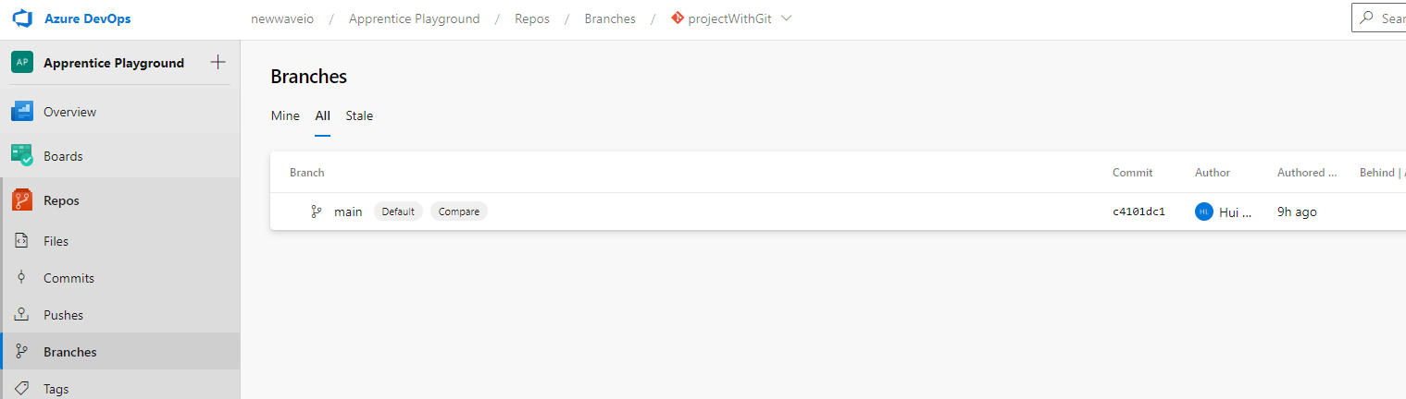

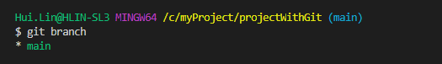

1. Create new branch in Azure DevOps on the Branches page

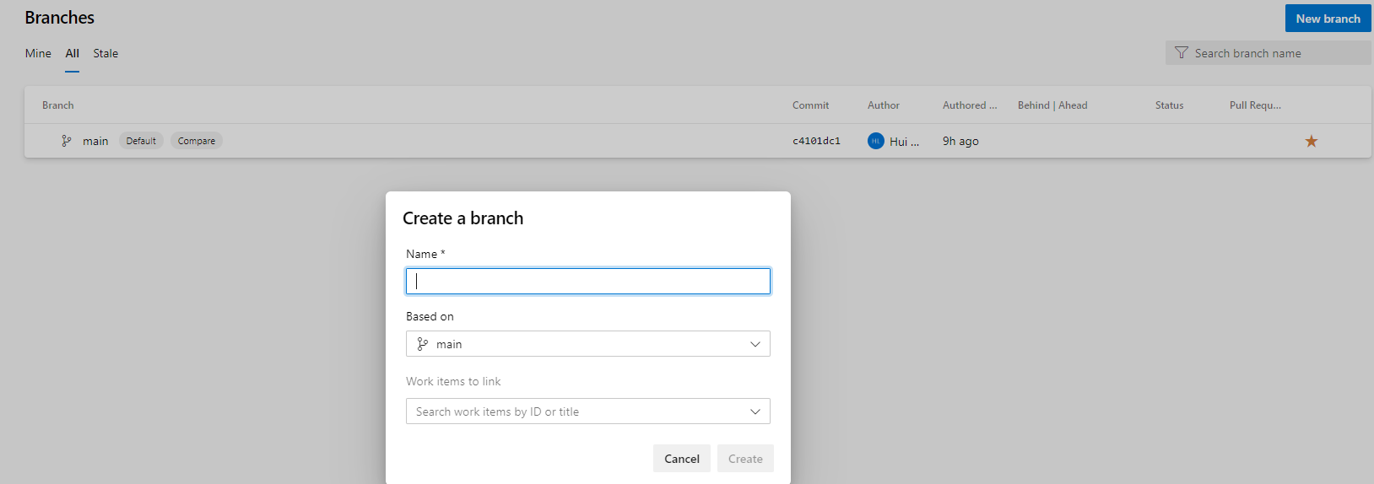

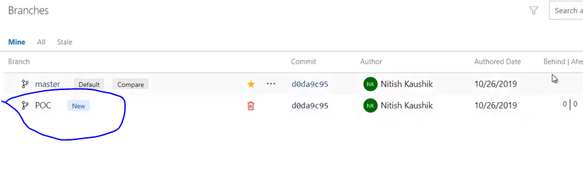

Behind/Ahead means how many commits the new branch is behind or ahead of its parent main branch.

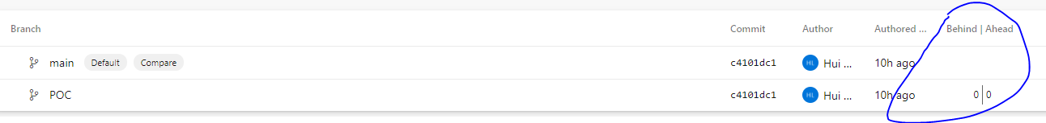

Using git pull command, you can create a new branch with the same name in your local repo.

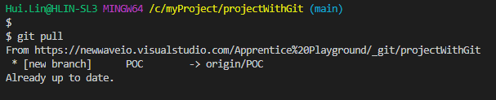

Using git check <new branch name> you can switch a branch in your local repository.

